ALCHEMY PVT. TUITIONS

CLASS : XIIth SUBJECT : CHEMISTRY
DATE : 27/09/2022 DPP NO. : 2
Topic :-HALOALKANES AND HALOARENES

1. What is the product A in the following?
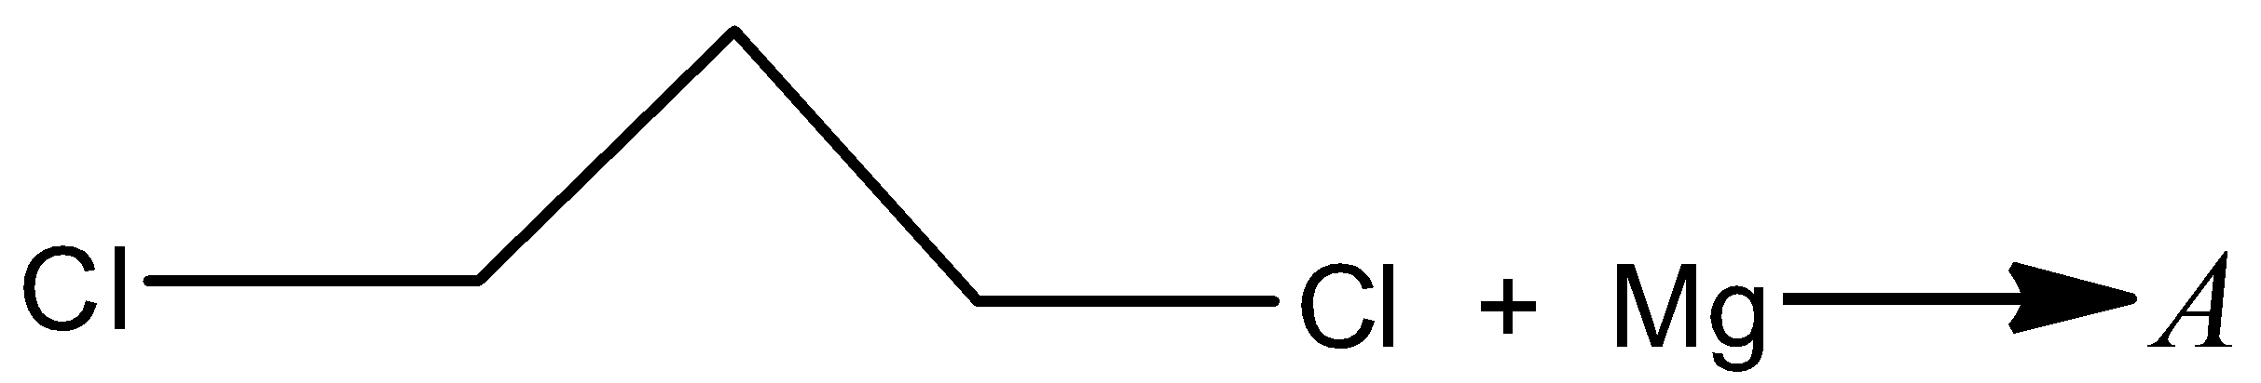
a) 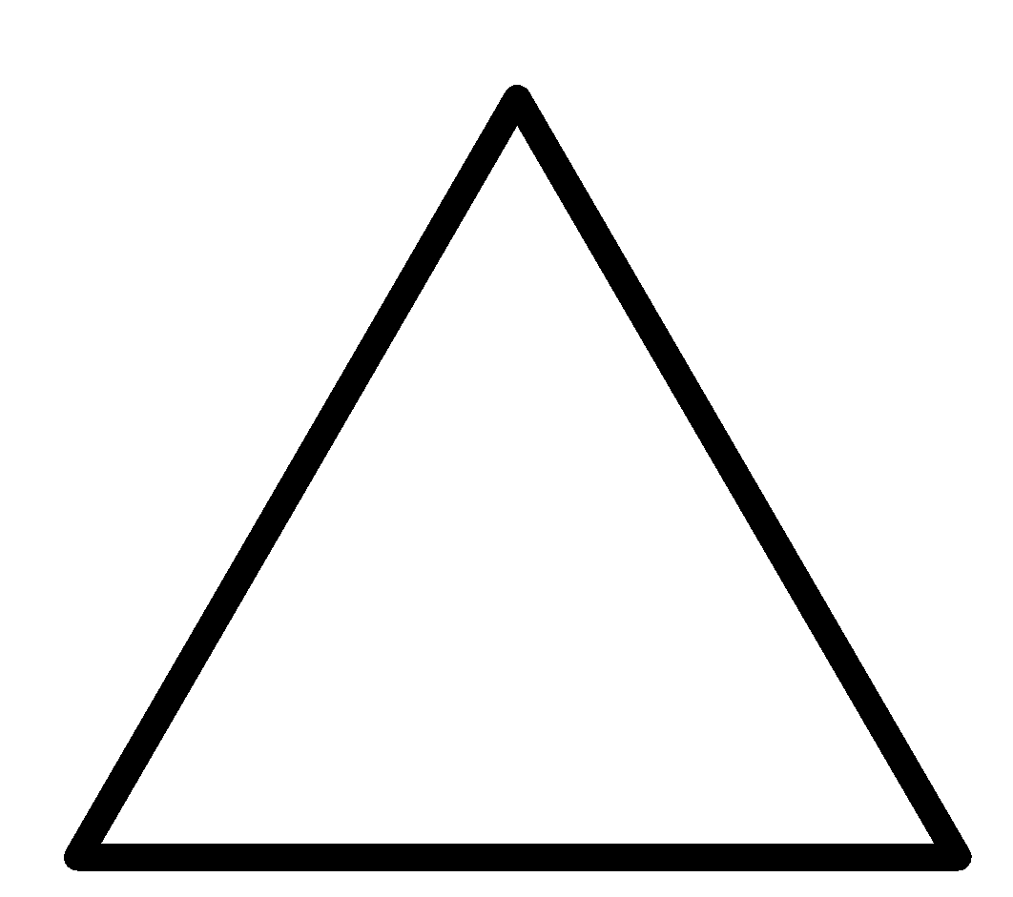 b) 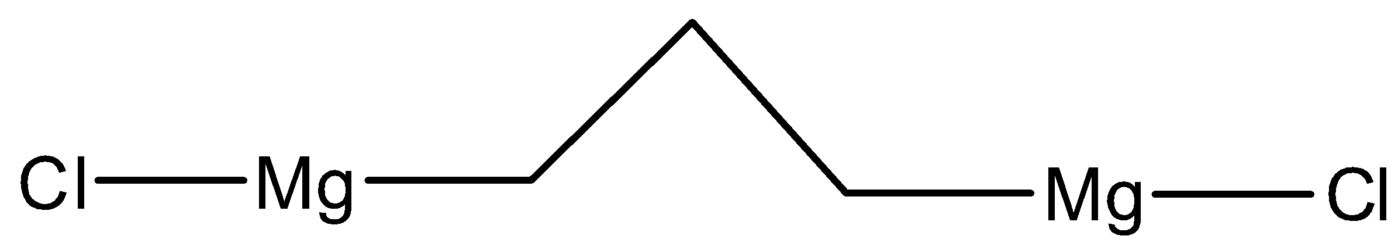
c) Both (a) and (b) d) None of the above

2. Identify (Z) in the following reaction series,
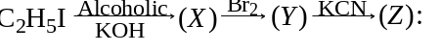
a) ${CH}_{3}$—${CH}_{2}$—CN b) 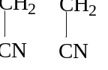 c) ${CH}_{2}$—${CH}_{2}$
⃒ ⃒
Br CN d) ${CH}_{ }$=${CH}_{ }$
⃒ ⃒
Br CN

3. How many structures of F is possible?
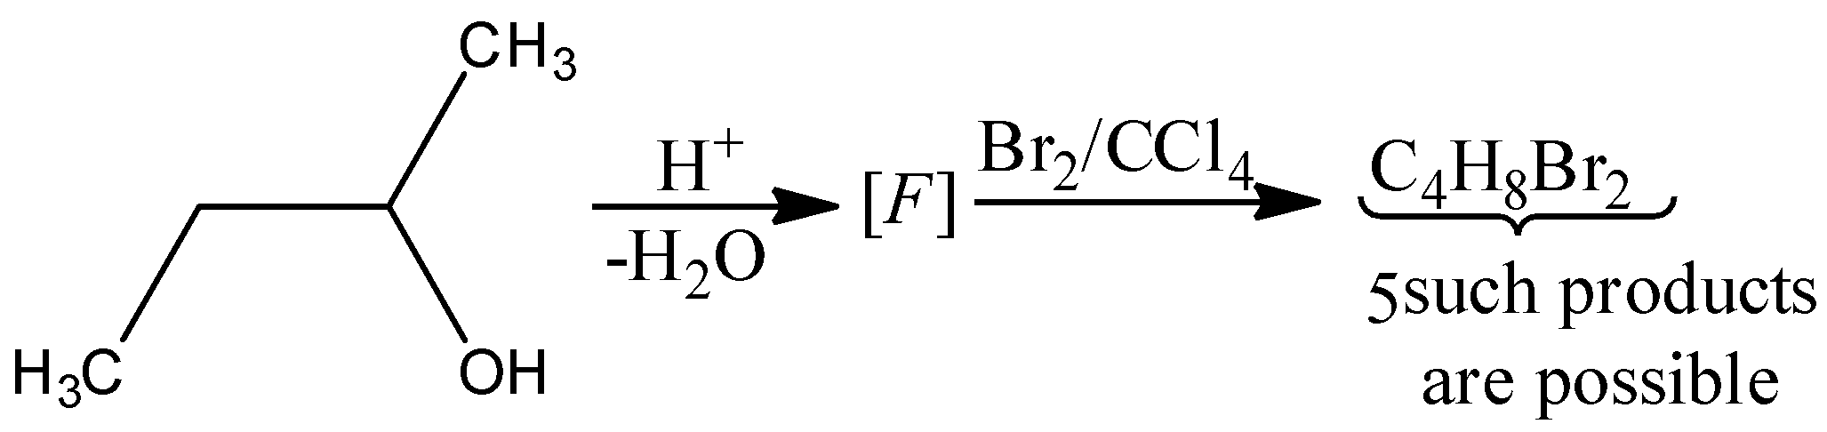
a) 2 b) 5 c) 6 d) 3

4. PVC plastics are produced by the polymerization of:
a) Vinyl acetate b) Allyl chloride c) Vinyl chloride d) Ethene

5. Ethylene dichloride can be prepared by the reaction of HCl and :
a) Ethane b) Ethylene c) Acetylene d) Ethylene glycol

6. Polymer of chloroethylene is:
a) PVC b) Teflon c) Nylon d) Terylene

7. Most readily hydrolysed halides is:
a) $C_{6}H_{5}Cl$ b) ${\left(C_{6}H_{5}\right)}_{2}CHCl$ c) $C_{6}H_{5}{CH}_{2}Cl$ d) ${\left(C_{6}H_{5}\right)}_{3}CCl$

8. What is the product of the reaction of 1, 3-butadiene with $Br_{2}$?
a) 1, 4-dibromo butene b) 1, 2- dibromo butene
c) 3, 4- dibromo butene d) 2, 3- dibromo-2-butene

9. Chlorobenzene gives aniline with
a) $NH_{3}/Cu_{2}0$b) $NH_{3}/H_{2}SO_{4}$c) $NaNH_{2}$d) None of the above

10. In the following compound, least number of monochlorination is possible
a) $CH_{3}CH_{2}CH_{2}CH_{2}CH_{3}$ b) 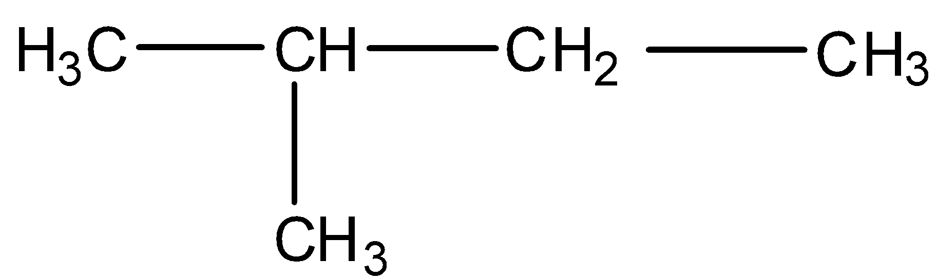
c) 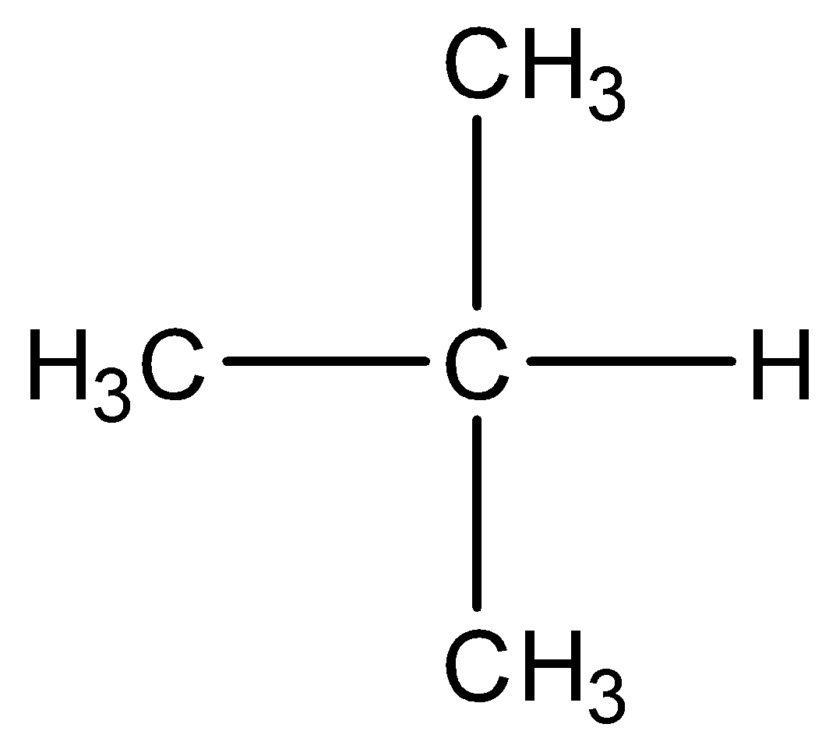 d) 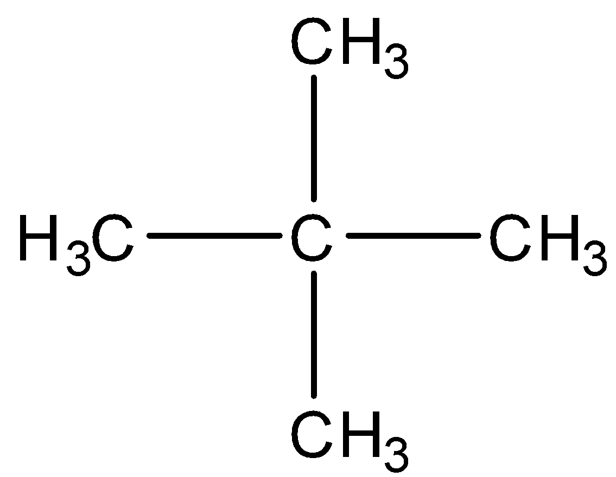

11. 2, 2-dichloro propane on hydrolysis yields
a) Acetone b) 2, 2-propane diol
c) Isopropyl alcohol d) Acetaldehyde

12. The product of vinyl chloride and HCl is a
a) $gem$ chloride b) Ethylidene chloride
c) 1, 1 dichloroethane d) All of the above are correct

13. Among the following, the molecule with the highest dipole moment is:
a) ${CH}_{3}Cl$ b) ${CH}_{2}{Cl}_{2}$ c) ${CHCl}_{3}$ d) ${CCl}_{4}$

14. ${CO}_{2} on reaction with C_{2}H_{5}MgBr and H_{2}O gives:$
a) Ethane b) Propionic acid c) Acetic acid d) None of these

15. Methyl chloride reacts with silver acetate to yield:
a) Acetic acid b) Methyl acetate c) Acetyl chloride d) Acetaldehyde

16. A compound $A$ of formula $C_{3}H_{6}{Cl}_{2}$ on reaction with alkali can give$B$ of formula $C_{3}H_{6}O$ or $C$of formula $C_{3}H_{4}$. $B$ on oxidation gave a compound of the formula $C_{3}H_{6}O_{2}$. $C$ with dilute
$H_{2}{SO}_{4}$ containing ${H_{g}^{ }}^{2+}$ ion gave $D$ of formula $C_{3}H_{6}O$, which with bromine and NaOH gave the sodium salt of $C_{2}H_{4}O_{2}$. Then $A$ is:
a) ${CH}_{3}{CH}_{2}{CHCl}_{2}$
b) ${CH}_{3}{CCl}_{2}{CH}_{3}$
c) ${CH}_{2}{ClCH}_{2}{CH}_{2}Cl$
d) ${CH}_{3}{CHClCH}_{2}Cl$

17. Compounds formed, when methyl amine is heated with chloroform in the presence of KOH is:
a) ${CH}_{3}$—C≡N b) ${CH}_{3}N^{+}$≡$C^{-}$ c) ${CH}_{3}—N^{-}$≡$C^{+}$ d) ${CH}_{3}{NHCH}_{3}$

18. Tertiary butyl alcohol gives tertiary butyl chloride on treatment with
a) $Conc. HCl/anhy. ZnCl_{2}$ b) KCN c) NaOCl d) $Cl_{2}$

19. The reaction of toluene with $Cl_{2}$ in presence of $FeCl_{3}$ gives predominantly
a) Benzoyl chloride b) Benzyl chloride
c) o-and p-chlorotoluene d) m-chlorotoluene

20. Which one of the following compounds when heated with KOH and a primary amine gives carbylamine test?
a) $CHCl_{3}$b) $CH_{3}Cl$c) $CH_{3}OH$d) $CH_{3}CN$

